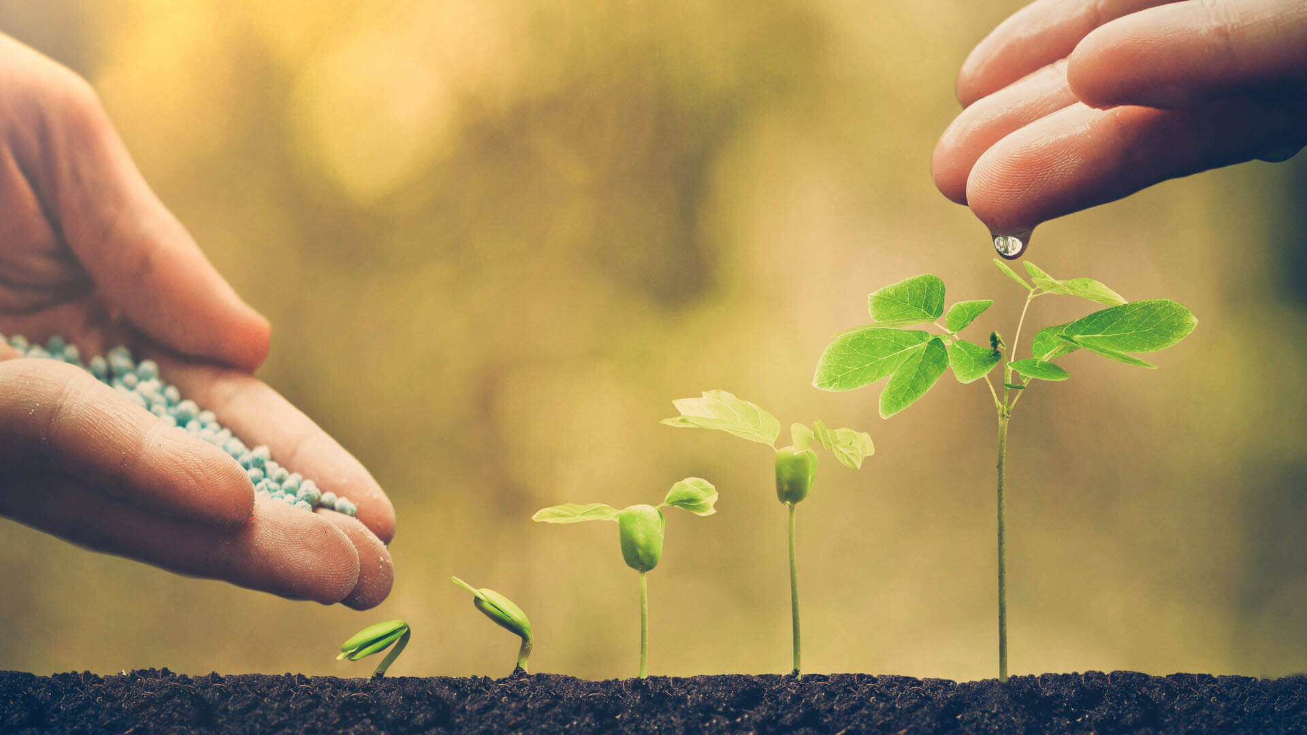
LAUDATO SI REFLECTION

SAVING CREATION: TILLING AND SUBDUING THE LAND

By: Sr. Flora Mae Lanuza, AR

We are all farmers or children of farmers because we are all came from our first parents, Adam and Eve who cultivated a large garden. Farming is the first employment which God given to man as His creation, as we read, “The Lord took man and put him into the garden to dress it and to keep it.” Farming or taking care of creation in this sense is the highest good, honorable and highest degree.

St. Ezekiel farm found at the back of school vicinity is a perfect place for farming or planting. It covers 1 ½ hectare of the land area. The farm is in mountainous landforms and you have to do a little bit mountain hiking in order to view the entire area of the farm. The area is a lovely spot where you can see different kind of fruits tress like, Avocado, Mango and Cotton fruit. It has fertile soil which is perfect for planting or gardening. It has a touch of earthly paradise because there you can hear pleasant sounds from the nature, see a beautiful nature and taste delicious fruits. When God put Adam and Eve in the garden, it means that man is designed to enjoy the natural object of beauty in creation. St. Ezekiel f farm is a place where you can also enjoy the natural beauty of creation. The farm is also need to be improved and cultivated because God commanded Adam to dress and keep the garden so also the farm needs to be improved and adorned by a hand of man for its prosperity. The perfect soil of the area is a very good place of tilling the subduing the land and fitted to do farming. In the Scared Scriptures, farming is a noble work. The best leaders of Israel were selected from the tillers of the soil and the keepers of flocks. David was tending the sheep when he was anointed as king. Elisha was plowing the twelve yokes of oxen when he called to be a prophet. It showed that we are called to till and subdue the land the Lord has given us. It is a noble work to do farming because according to some, farming is a favorable healthy action of the mind. St. Ezekiel farm is a perfect place for gardening and tilling the soil to adapt and restore healthy tone of the mind and body and to express gratitude to God for the gift of beautiful creation. God provided with the touch of His loving hands so we too take care of it through the touch of our human hands. Here Divine and Human connection has been magnify and dignify.

Sisters, teachers and students who are exhausted in life and busy work due to hectic schedule can visit the farm for relaxation. Planting is the best activity to do in the farm and also hiking and harvesting fruit trees. The farm has its natural beauty which brings perfect encounter with God’s creation and can lead you to a deeper reflection in life and connection with God.
I believe that to do farming and planting in our small farm area cultivates the value for care for creation. Through the school program like, tree planting, gardening and nature trip will help the students, teachers and administrators grow in the love for God’s creation. We are also helping the community by inspiring them to plant trees as a way of protecting the environment and natural resources. This is our small way to combat with the larger abuse and irresponsible consumption of creation.
“Everyone talents and involvement are needed to redress the damage cause by human abused of God’s creation.”
Laudato Si, 14
