**4 OCTOBER. It’s the feast of St Francis, the patron saint of animals. Let’s Rejoice!**

**ARE YOU A PET LOVER, DO YOU STILL HAVE FOND MEMORIES OF THE PETS YOU LOVED AND LOST ? Why not join us on FRIDAY MORNING 4 OCTOBER At 11am in the clubhouse to praise and thank God for animals and pets and the blessing they are**

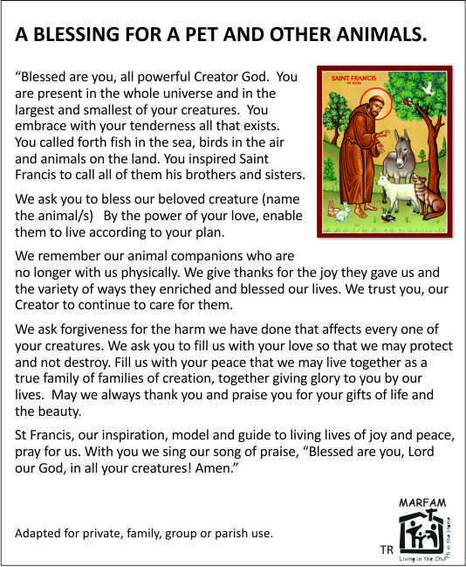

**ALL THINGS BRIGHT AND BEAUTIFUL**

* + ***Refrain:*  
    All things bright and beautiful,  
    All creatures great and small,  
    All things wise and wonderful:  
    The Lord God made them all.**

1. **Each little flow’r that opens,  
   Each little bird that sings,  
   He made their glowing colors,  
   He made their tiny wings.**
2. **The purple-headed mountains,  
   The river running by,  
   The sunset and the morning  
   That brightens up the sky.**
3. **The cold wind in the winter,  
   The pleasant summer sun,  
   The ripe fruits in the garden,  
   He made them every one.**
4. **The tall trees in the greenwood,  
   The meadows where we play,  
   The rushes by the water,  
   To gather every day.**
5. **He gave us eyes to see them,  
   And lips that we might tell  
   How great is God Almighty,  
   Who has made all things well**

St Francis Day Blessing MdO 4 October 2024

Bring pics. Blessing prayer and hymn. Sit at tables

1. Welcome, intro. Context and share Season of Creation (other sheet) animals and pets. General.
2. Reading blessing line by line, reflect
3. Share on our own animal/pet. Who, what, favourite memories. Pics. Pearl’s baby birds.
4. Ask God to bless pet and us.
5. Encourage us to work for pet care. biodiversity loss, SPCA, AACL +
6. Coffee, tea. Rusks

INVITE SoC closing 3pm .